Sample school newsletter copy:

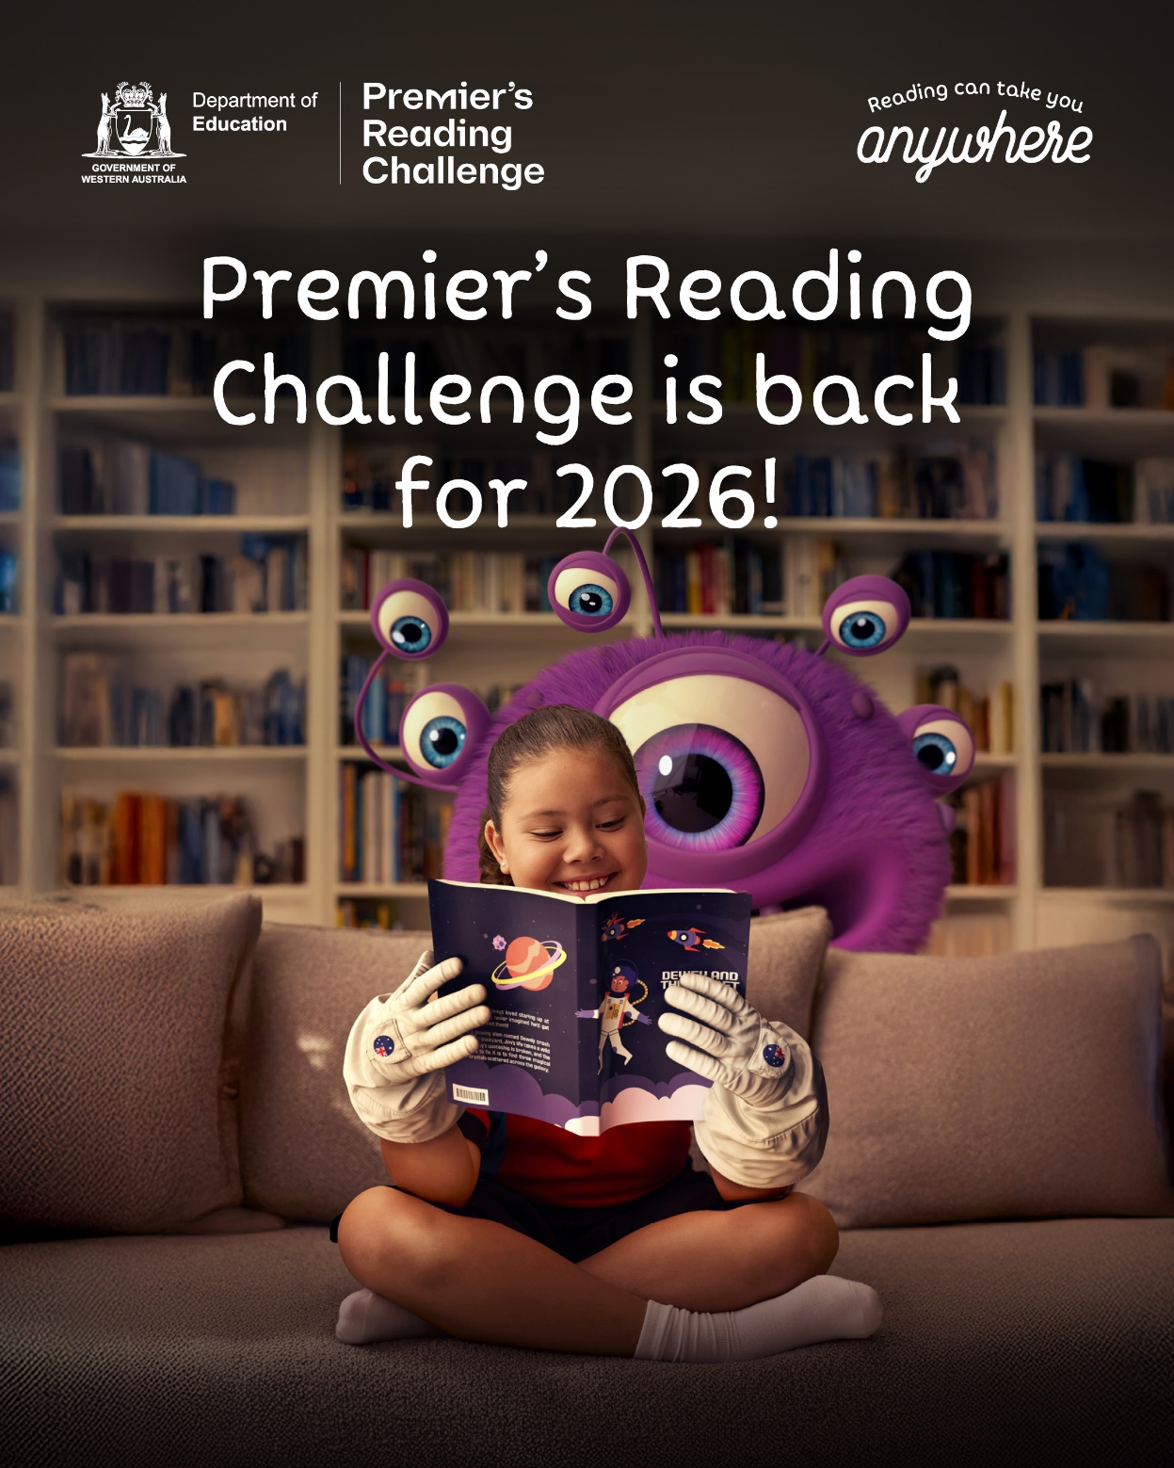

Discover the magic of reading
Register your child for the Premier's Reading Challenge! From 23 March to 12 June 2026, students from Kindergarten to Year 12 can discover the joy of reading and log their progress for a chance to win weekly prizes.
Visit premiersreadingchallenge.wa.edu.au for more information.

