Newsletter article for schools

Premier’s Reading Challenge

Primary
Join the adventure!
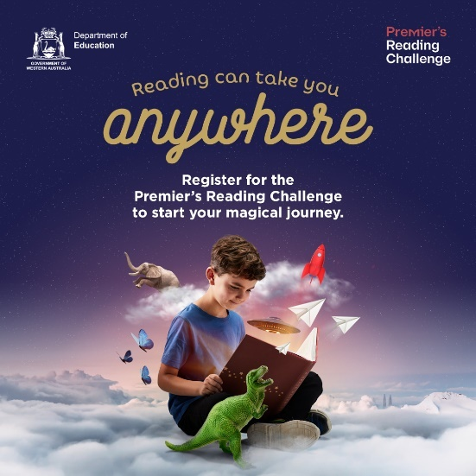
We encourage you to join us in unlocking the wonderful world of reading for your children. Help them to join the Premier’s Reading Challenge. Will they fly above the clouds, dive into the ocean or jump into a rocket ship? All students from Kindergarten to Year 10 are challenged to read 12 books by 9 September 2022.
You can help your children sign up via the website, choose their own avatar and log all the books they read over the course of the Challenge. Weekly prizes will be awarded to students who log a book that week, with major prizes drawn when the challenge ends.
Books don’t have to be in English – children are encouraged to read books in their first language.
There are extraordinary tourism prizes to be won each week.
Sign up your children on the website to begin their magical journey.

Secondary
Join the adventure!
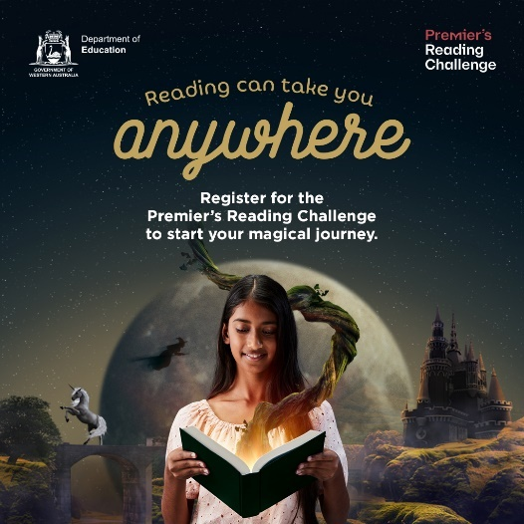
We encourage you to join us in unlocking the wonderful world of reading for your children. Help them to join the Premier’s Reading Challenge. Will they fly above the clouds, dive into the ocean or jump into a rocket ship? All students from Kindergarten to Year 10 are challenged to read 12 books by 9 September 2022.
Your children can register via the website, choose their own avatar and log all the books they read over the course of the challenge. Weekly prizes will be awarded to students who log a book that week, with major prizes drawn when the challenge ends.
Books don’t have to be in English – families are encouraged to read books in their first language.
There are extraordinary tourism prizes to be won each week.
Children can sign up on the website to begin their magical journey.

